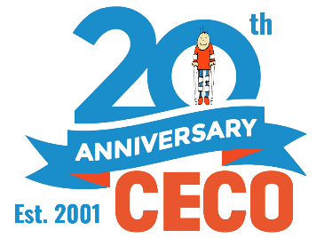
Contact Information:
The Conductive Education Center of Orlando (CECO)
407-671-4687
cecosocial@ceco.org

CECO’s 20th Anniversary:
The Future of Learning for Children and Adults with Disabilities

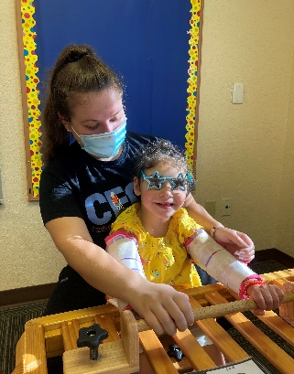
The Conductive Education Center of Orlando (2021)- A center for children and adults with neurological motor disabilities, the Conductive Education Center of Orlando (CECO), is proud to be celebrating its 20th anniversary here in the Central Florida community. CECO provides unique Conductive Education programming to children and adults with neurological motor disabilities, like Cerebral palsy and spina bifida, through nine diverse programs including a new virtual conductive education platform. Conductive Education is a unique modality of education originating in Hungary that combines physical, social, and cognitive educational modalities to maximize impact.

Over the last 20 years, CECO has served over 100 families annually, with many families travelling from all over the country to attend programming. CECO has also fostered the creation of a community of families with children of all ages with neurological motor disabilities, creating a hub for shared resources, community, and normalcy for parents.

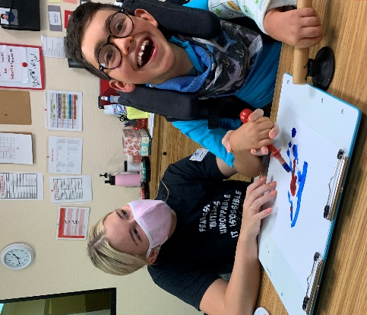
While the last year and a half has certainly been difficult for so many local nonprofit organizations, CECO has been able to pivot, and took the COVID-19 pandemic as an opportunity to pioneer a virtual conductive education platform. Due to the physical manipulation often required in conductive education programming, this was previously thought to be an impossible task. The expansion of CECO’s programming to a virtual platform expands CECO’s impact on a national and international level.

Looking forward to the next twenty years, CECO is excited to continue to work towards creating unique programming for children and adults of all ages with neurological motor disabilities here in the Central Florida community and beyond.

If you’d like to learn more about how you can support CECO’s impact here in our community, visit www.ceco.org or visit our Facebook page for more information. Tickets and sponsorship opportunities are also available for upcoming events like CECO’s Night of Dreams Gala on Friday, September 17th.

